**PChem Demo Descriptions**

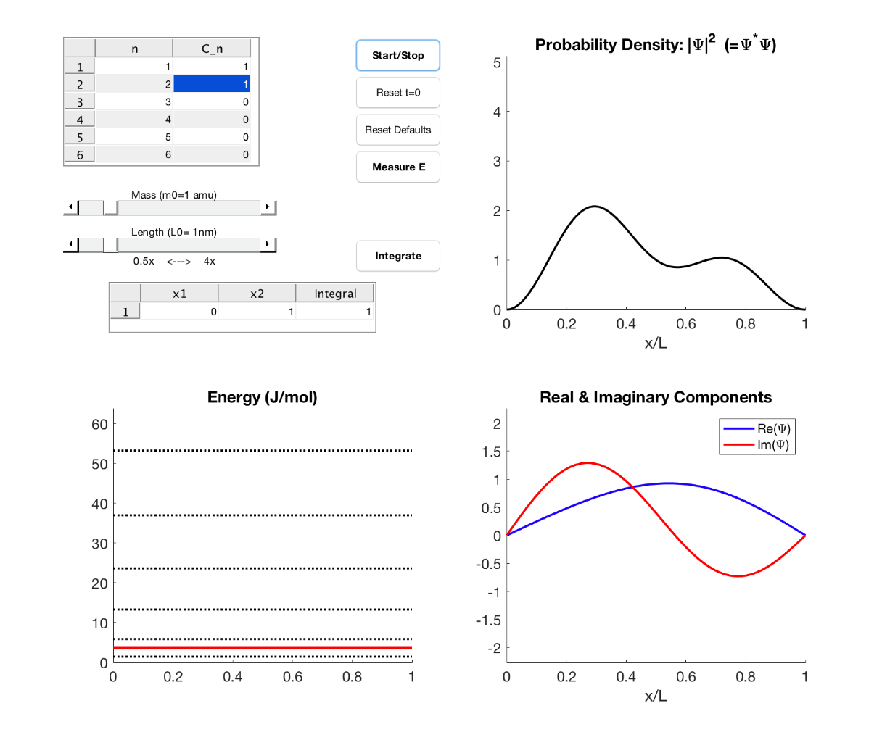

*PibSim1.m*

This demonstration illustrates the wavefunctions for the quantum particle in a box, including superposition states. The input table (upper left corner) can be edited to change the quantum number (n) and coefficient (cn) in the general state: . Time evolution can be observed with the Start/Stop button, and a probabilistic collapse of the wavefunction can be seen with the Measure button. The mass of the particle and box length are adjustable with sliders, and the integrated probability density can be computed over any position range with the lower input table and the Integrate button.

Probability density is plotted in the upper right, while real and imaginary components of the wave, as well as total system energy, are additionally shown in the two bottom plots. The probability density plot has a fixed scale so that relative comparisons can be made. Coefficients are renormalized in the plotting and integration routines but will appear in the table as entered.

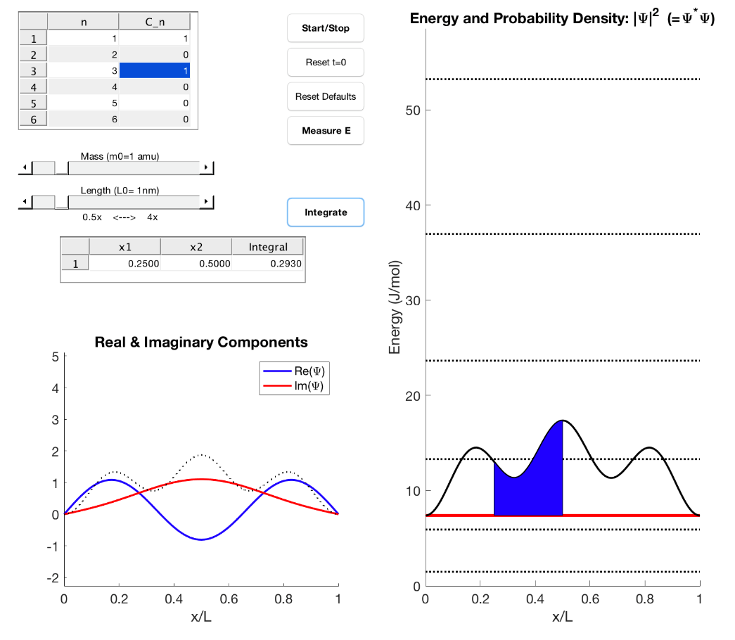*PIBSim2.m*

This demonstration illustrates the wavefunctions for the quantum particle in a box, including superposition states. The input table (upper left corner) can be edited to change the quantum number (n) and coefficient (cn) in the general state: . Time evolution can be observed with the Start/Stop button, and a probabilistic collapse of the wavefunction can be seen with the Measure button. The mass of the particle and box length are adjustable with sliders, and the integrated probability density can be computed over any position range with the lower input table and the Integrate button.

This version of the simulation overlays the probability density with the energy in a single plot (y-axis for ${\left|Ψ\right|}^{2}$ is arbitrary). Coefficients are renormalized in the plotting and integration routines but will appear in the table as entered. Real and imaginary components of the wave are shown in the other plot, with the probability density overlaid to illustrate their relationship.

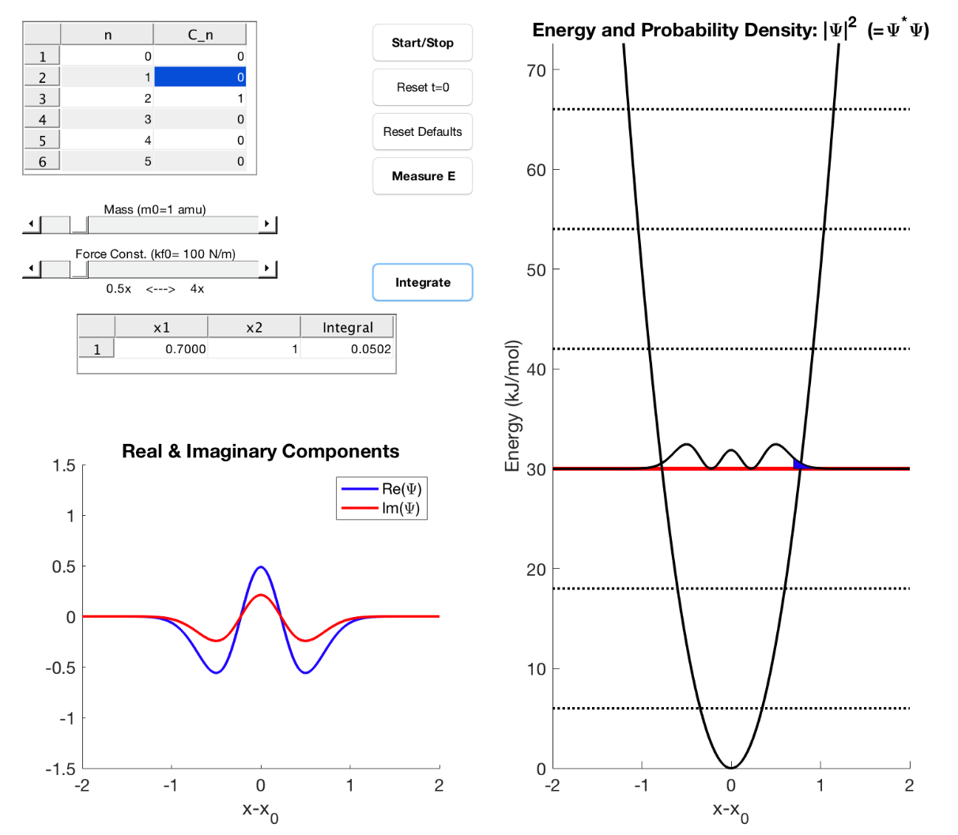*HarmonicSim.m*

This demonstration illustrates the wavefunctions for the quantum harmonic oscillator, including superposition states. The input table (upper left corner) can be edited to change the quantum number (n) and coefficient (cn) in the general state: $Ψ=c_{n}\sum{ψ_{n}}$, in which $ψ_{n}\left(x\right)=N_{n}H_{n}(y)e^{-\frac{y^{2}}{2}}$, where $H_{n}$ are the *n*th Hermite polynomials and $y=x·{\left(\frac{mk_{f}}{ℏ^{2}}\right)}^{1/4}$. Time evolution can be observed with the Start/Stop button, and a probabilistic collapse of the wavefunction can be seen with the Measure button. The mass of the particle and harmonic force constant are adjustable with sliders, and the integrated probability density can be computed over any position range with the lower input table and the Integrate button.

The simulation overlays the probability density with the energy in a single plot (y-axis for ${\left|Ψ\right|}^{2}$ is arbitrary). Coefficients are renormalized in the plotting and integration routines but will appear in the table as entered. Real and imaginary components of the wave are shown in the lower left plot.

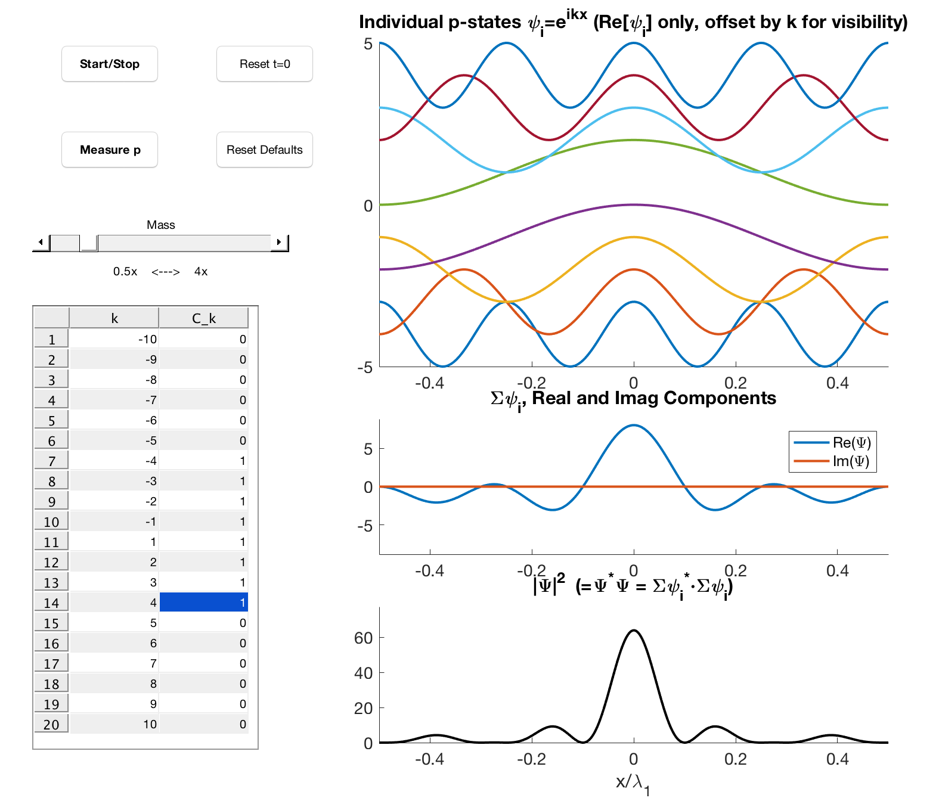

*FreeParticle.m*

This simulation visualizes a free particle wave packet of momentum states expressed as $Ψ=\sum{{c_{k}ψ}_{k}}$ where each basis function ${ψ_{k}=e}^{ikx}$ is a momentum eigenstate indexed by an integer - $∞$ to $∞$. The input table can be edited to change the quantum number (k) and coefficients (cn) of contributing waves. Time evolution can be observed with the Start/Stop button, and a probabilistic collapse of the wavefunction can be seen with the Measure button.

Each contributing wave is plotted with an offset for clarity in the top plot, while the center plot shows the real and imaginary components of the superposition and the bottom plot shows the probability density in space. The matlab function may be called with no argument for manual editing of the table, or, with a vector listing the eigenvalues of the states to be plotted – i.e. “ FreeParticleSim([-50:-1;1:50]) ” will plot 100 contributing states, with each *k* up to ±50.